WEEK 2
Create a Node.js application for a user login system
>>> Create login.html File (For the Login Form)

Login.html
<form action="/login" method="post">
<h2>Login Page</h2>
Username: <input type="text" name="username"><br><br>
Password: <input type="password" name="password"><br><br>
<input type="submit" value="Login">
</form>

>>>Create login.js File (Node.js Server)

Login.js
const http = require('http');
const fs = require('fs');
const querystring = require('querystring');

const server = http.createServer((req, res) => {
if (req.method === 'GET') {
fs.readFile('login.html', (err, data) => {
res.writeHead(200, { 'Content-Type': 'text/html' });
res.end(data);
});
} else if (req.method === 'POST' && req.url === '/login') {
let body = '';
req.on('data', chunk => {
body += chunk.toString();
});
req.on('end', () => {
const parsed = querystring.parse(body);
const username = parsed.username;
const password = parsed.password;

if (username === 'admin' && password === '12345') {
res.end('Login Successful!');
} else {
res.end('Invalid Credentials. Try again.');
}
});
}
});

server.listen(3000, () => {
console.log('Server running at http://localhost:3000/');
});

OUTPUT:1

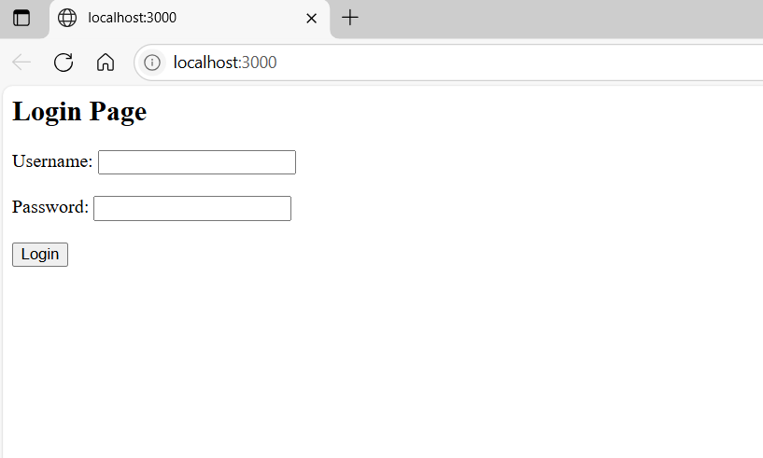
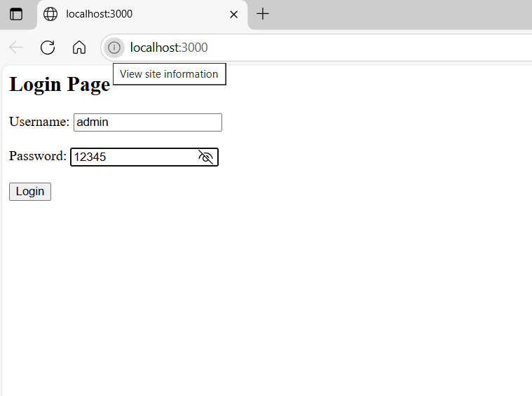
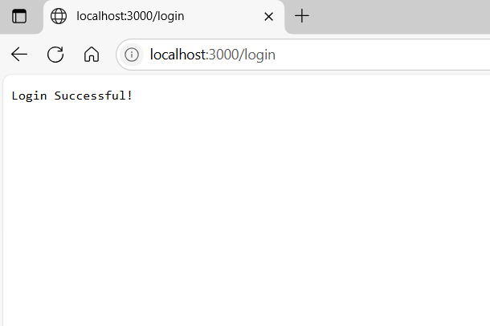
Output:2

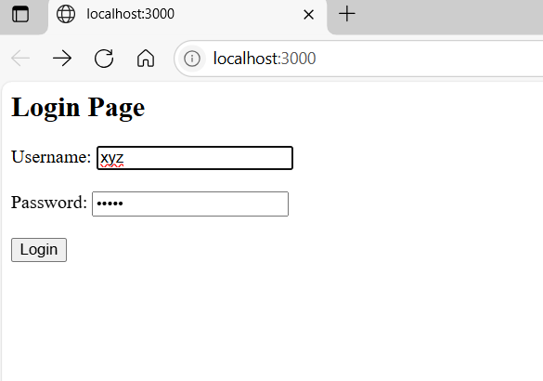
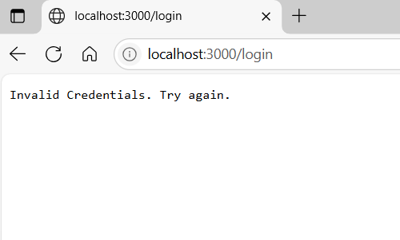

Viva Questions
- What is Node.js and why is it used?
- What does the http module do in Node.js?
- Why do we use the fs module in this program?
- What is the role of the querystring module in the login system?
- What is the difference between GET and POST methods in HTTP?
- What is the purpose of req.on('data') and req.on('end')?
- What does the res.writeHead() method do?
- Why do we use server.listen(3000)?

Underrstanding the code
- Use require to import built-in modules (http, fs, and querystring).
- http.createServer() creates the server.

if (req.method === 'GET') {
/* the browser sends a GET request (when first opens the page), show the login form*/

fs.readFile('login.html', (err, data) => {
res.writeHead(200, { 'Content-Type': 'text/html' });
res.end(data);
});
/*read the login form file and send it as a response. So the browser displays the login form.*/

} else if (req.method === 'POST' && req.url === '/login') {
/*Now if the user submits the form (which sends a POST request), then process the login*/
let body = '';
req.on('data', chunk => {
body += chunk.toString();
});
/*Data sent from the form arrives in chunks. then collect it into a string*/
req.on('end', () => {
const parsed = querystring.parse(body);
const username = parsed.username;
const password = parsed.password;
/*Once all chunks are received, we parse the data to get the username and password.*/
if (username === 'admin' && password === '12345') {
res.end('Login Successful!');
} else {
res.end('Invalid Credentials. Try again.');
}
/*check if the credentials are correct. If yes, show success. If not, show error.*/
server.listen(3000, () => {
console.log('Server running at http://localhost:3000/');
});
/*the server listens on port 3000*/

